**MINI PROJECT-II**

**(2021-22)**

**Head Over Meals**

**(A Food Website)**

**SYNOPSIS**



**Institute of Engineering & Technology**

**Team Members**

Muskan Srivastava

(181500406)

Kushagra Dixit

(181500344)

Supervised By

**Mr. Pankaj kapoor**

**Technical Trainer**

Department of Computer Engineering & Applications

**INTRODUCTION**

The Online Food Ordering System has been developed to override the problems prevailing in the practice manual system.

This software is supported to eliminate and, in some cases, reduce the hardships faced by the existing system. Moreover, this system is designed for the particular need of the company to carry out operations in a smooth and effective manner.

No formal knowledge is required by the user to use this system. It’s a user-friendly system. Online Food Ordering System can lead to error free, secure, fast and reliable system. It can assist the user to focus on other activities rather to keep an eye on the record keeping.

Thus, it will help the Organization in better utilization of resources. Every Organization whether big or small has challenges to overcome and managing the information of Item category, Food, Customer, Delivery Address, Order.

**ABSTRACT**

The Purpose of Online Food Ordering System is to automate the existing system by the help of Computerized equipments and fully fledged computer software fulfilling their requirements so that their valuable data can be stored for a longer period with easy accessing and manipulation of the same.

Online Food Ordering System can lead to error free, secure, fast and reliable system. It can assist the user to focus on other activities rather to keep an eye on the record keeping.

**OBJECTIVE OF THE PRODUCT**

* The main Objective of the Project on Online Food Ordering System is to manage the details of food, Item Category, Shopping Cart, Customer, Order.
* It manages all the Information about food, delivery address, order, Food.
* The Project is totally built at administrative end and thus only the administrator can only access

**Modules of Online Food Ordering System**

* Food Management Module: Used for managing the Food details.
* Order Module: Used for managing the details of Order
* Delivery Address Module: Used for managing the details of Delivery Address
* Item Category Management Module: Used for managing the information and details of the Item Category.
* Shopping Cart Module: Used for managing the Shopping Cart details
* Customer Module: Used for managing the Customer information
* Login Module: Used for managing the login details
* Users Module: Used for managing the users of the

**SOFTWARE SPECIFICATION**

* **Technology Implemented:**

1. **MongoDB -** MongoDB is a document database with the scalability and flexibility that you want with the querying and indexing that you need.
2. **Express.js** – Express.js is a Node js web application framework, which is specifically designed for building single-page, multi-page and hybrid web applications.
3. **Angular 7** – Angular 7 is a frontend framework.
4. **Node.js** – we are using Node.js as backend technology. It is an open source server environment. It uses java script on server.

The combination of these four technologies is called **‘MEAN Stack’**.

**HTML**: For user interface.

**CSS**: For making interfaces more attractive and stylish.

**Bootstrap 4**: For making website responsive and more attractive.

* **Language Used:** JavaScript
* **Database:** MongoDB
* **User Interface Design:** Website
* **Web Browser:** Chrome

**HARDWARE REQUIREMENTS**

* **Processor:** intel i5
* **Operating System:** Windows 10
* **RAM;** 8GB
* **Hardware Devices:** Computer System
* **Hard Disk:** 256 GB

**FUTURE SCOPE**

**In a nutshell, it can be summarized that the future scope of the project circles around maintaining information regarding:**

* We can give more advance software for Online Food Ordering System including more facilities.
* We will host the platform on online servers to make it accessible worldwide.
* Integrate multiple load balancers to distribute the loads of the system.
* Create the master and slave database structure to reduce the overload of the database queries.
* Implement the backup mechanism for taking backup of codebase and data base on regular basis on different servers.

The above-mentioned points are the enhancements which can be done to increase the applicability and usage of this project.

Here we can maintain the records of Food and Item Category. Also, as it can be seen that now-a-days the players are versatile, i.e. so there is a scope for introducing a method to maintain the Online Food Ordering System.

Enhancements can be done to maintain all the Food, Item Category, Shopping Cart, Customer, Order.

We have left all the options open so that if there is any other future requirement in the system by the user for the enhancement of the system then it is possible to implement them.

In the last we would like to thanks all the persons involved in the development of the system directly or indirectly.

We hope that the project will serve its purpose for which it is develop there by underlining success of process.

**The features of this system are the following:**

- order product online

- upload product design online

- add, edit, delete product

- send order confirmation via email

- manage online order

- Ajax hierarchical combo box for payment method.

- add delivery charge outside the coverage area

- secure reservation

- forum for customer comments about the site

- generates various report

- and many more.

**Input Data and Validation of Project on Online Food Ordering System**

* Each Form of food item, category, delivery does not accept a blank space.
* Avoiding Errors in Data.
* All the fields such as customer, cart, food item is validated and does not take invalid values.
* Controlling amount of input.
* Actual Testing done manually.

**Software Design**

**Use Case Diagram:**

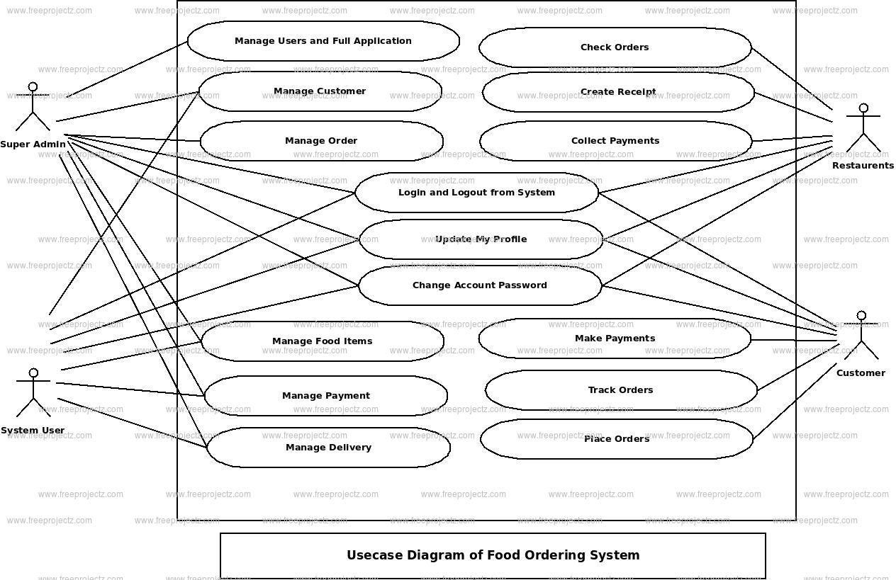

**Data Flow Diagram:**

**Level-0-DFD:**

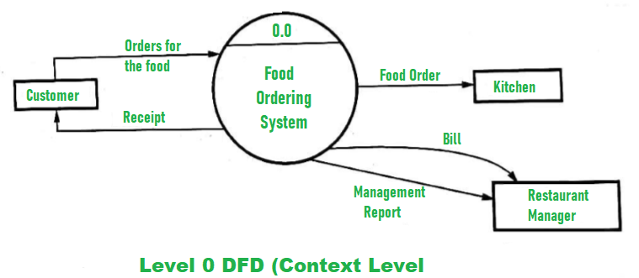

**Level-1-DFD:**

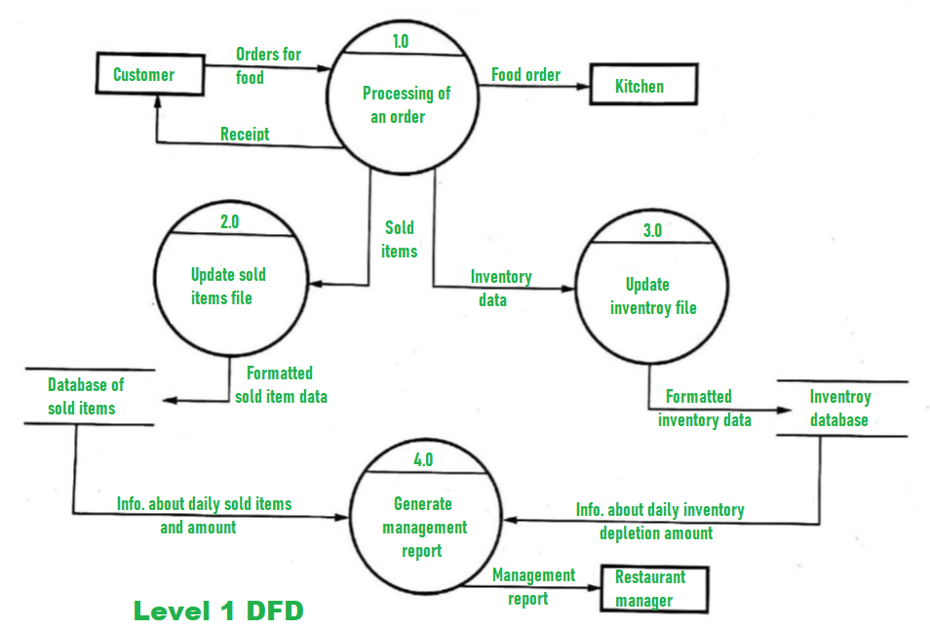

**Level-2-DFD:**

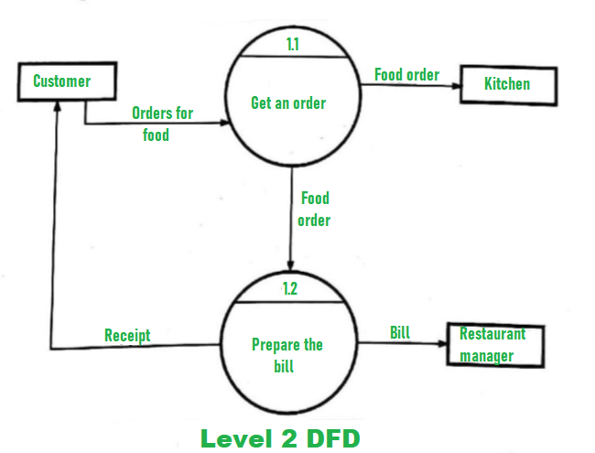

**Entity Relationship Diagram:**

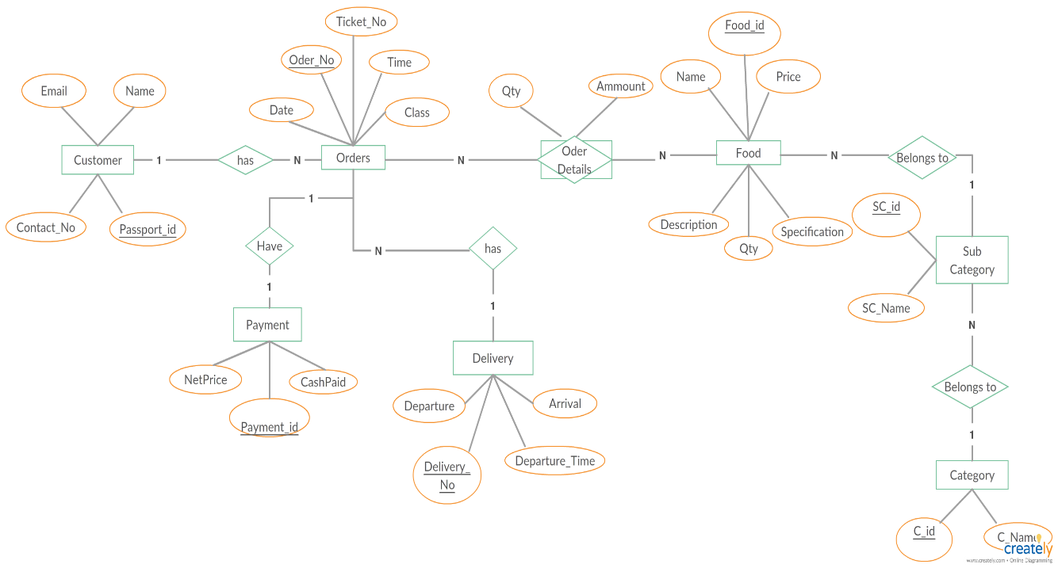

**Snapshots of the Project:**

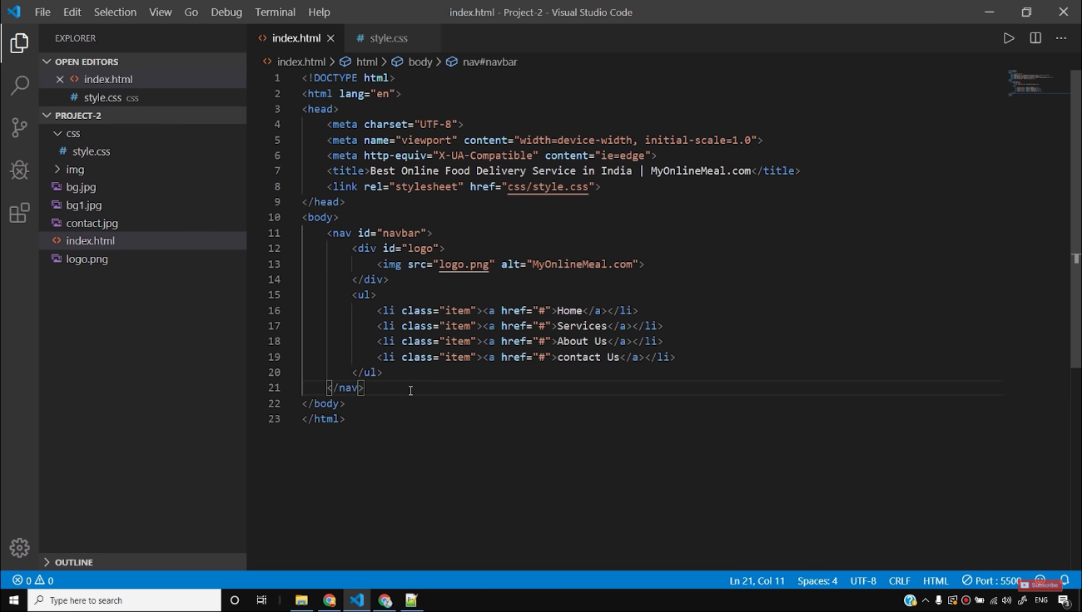

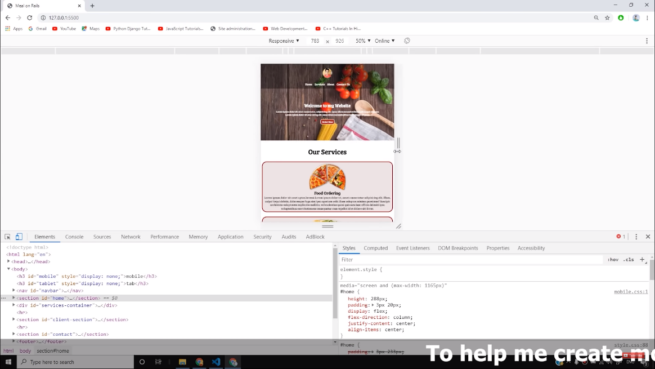

**Styling of navigation bar:**

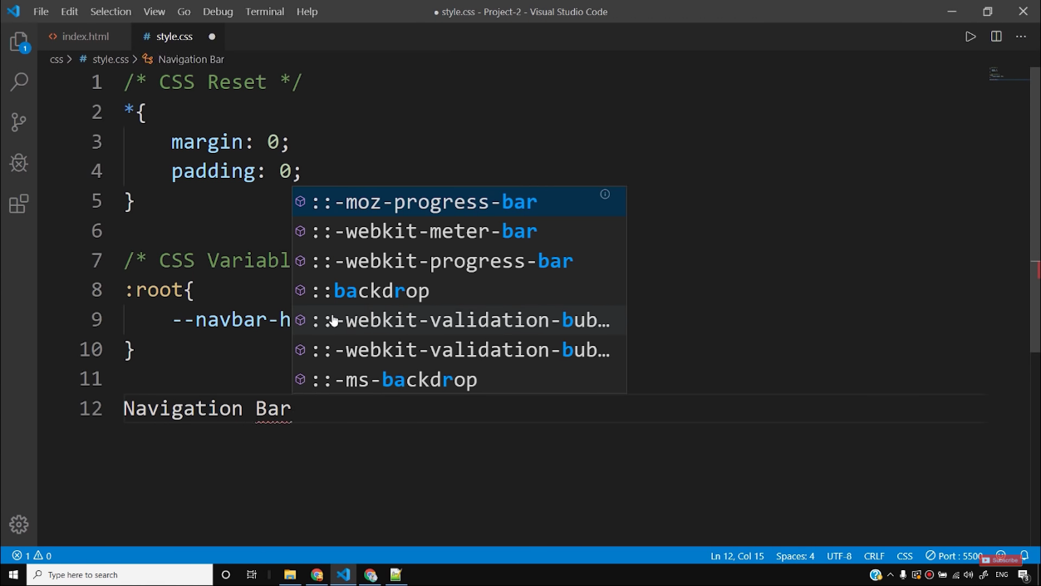

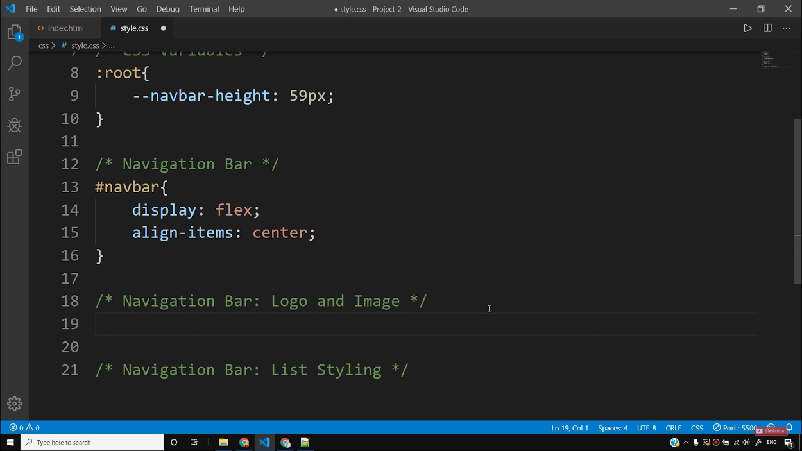

**Adding a background Image:**

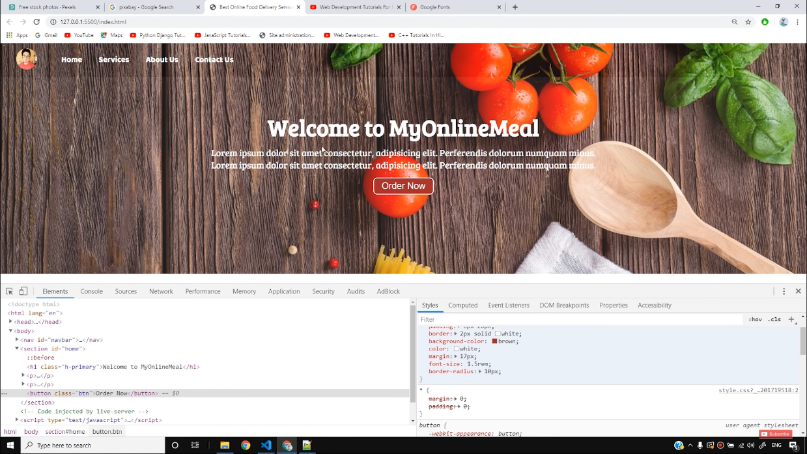

**Services classes provided by us:**

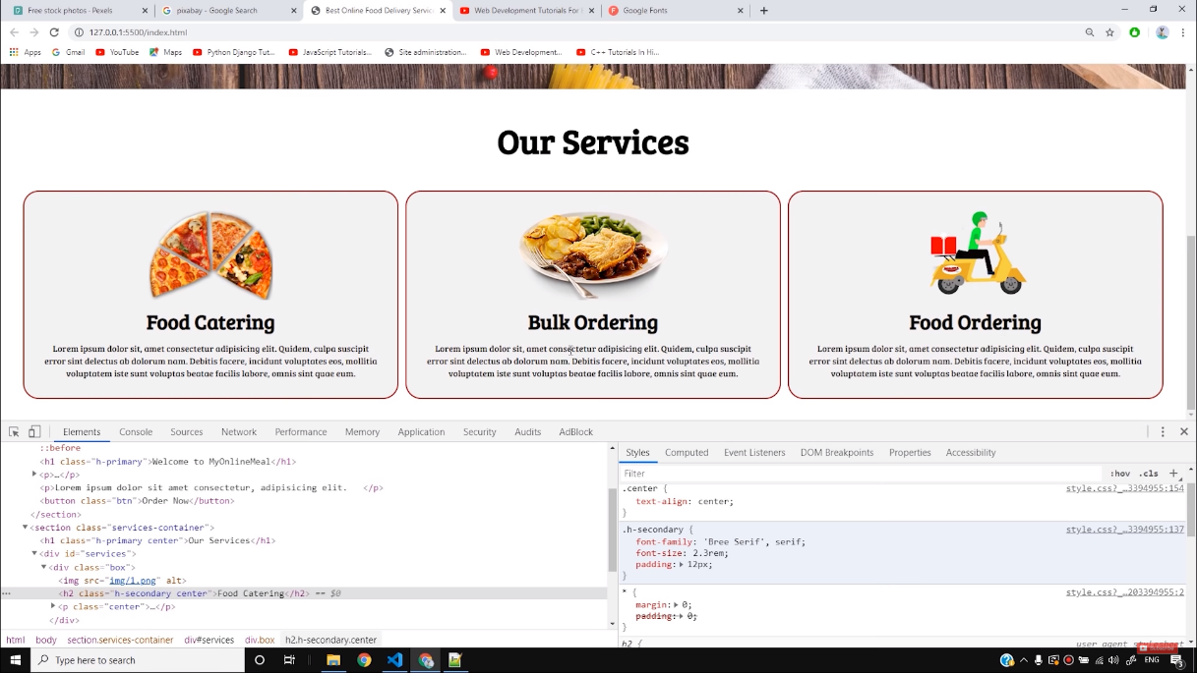

**Adding Client Section to the page:**

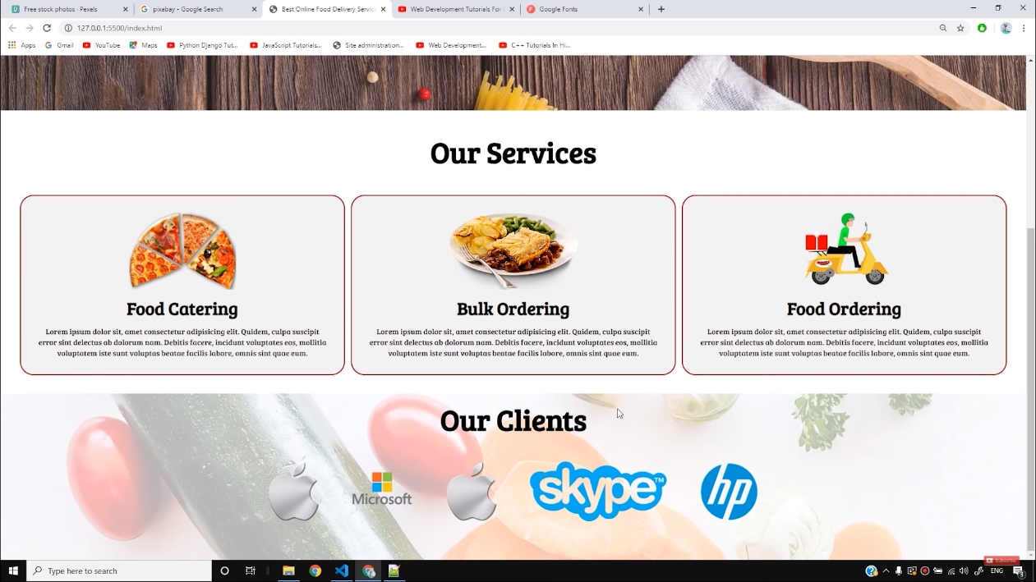

**References:**

* [**http://www.w3schools.com/**](http://www.w3schools.com/)
* [**http://www.googlefonts.com/**](http://www.googlefonts.com/)
* **Google**
* **YouTube (http://www.youtube.com/)**
* **GitHub**